Object-Oriented Design
1. Use Case Name: View Grades (Simple)
- Scenario: Student or Parent checks academic performance for a specific term.
- Triggering event: User selects the “View Grades” option from the dashboard.
- Brief description: Retrieves and displays a student's grades and calculated GPA for a selected academic term.
- Actors: Primary: Student or Parent. Secondary: Registrar (data source).
- Stakeholders: Students; Parents; Teachers; Academic Advisors.
- Related use cases: Enter or Update Grades (grades must be entered first).
- Preconditions: * User is authenticated and logged into the system.
  - Grade records for the requested term have been published.
- Postconditions: * Grade report is displayed; GPA is calculated and shown.
- Flow of activities:
  - Actor requests “View Grades” and selects a specific academic term.
  - System (GradeController) validates the student session.
  - System (GradeDataAccess) queries the database for matching GradeRecords.
  - System calculates the term GPA based on retrieved scores and credits.
  - System displays the grade list and GPA summary on the GradeReportUI.
- Exception conditions:
  - No grades found for selected term → display "No records available" message.
  - Session timeout → redirect to Login screen.

First Cut Design Class Diagram :
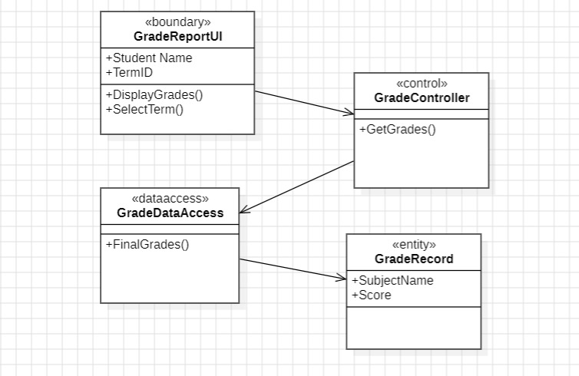

CRC Cards : 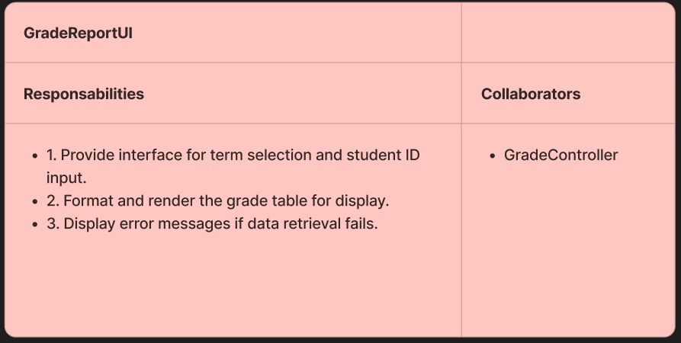
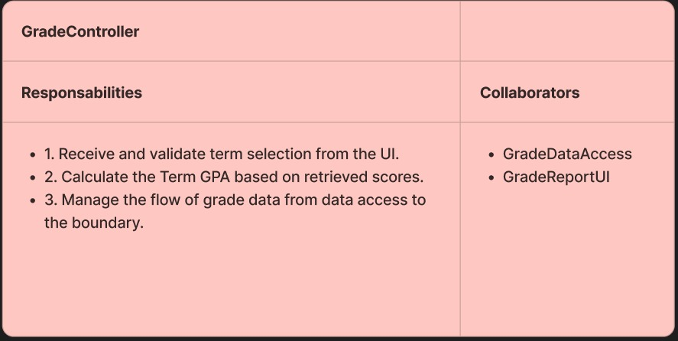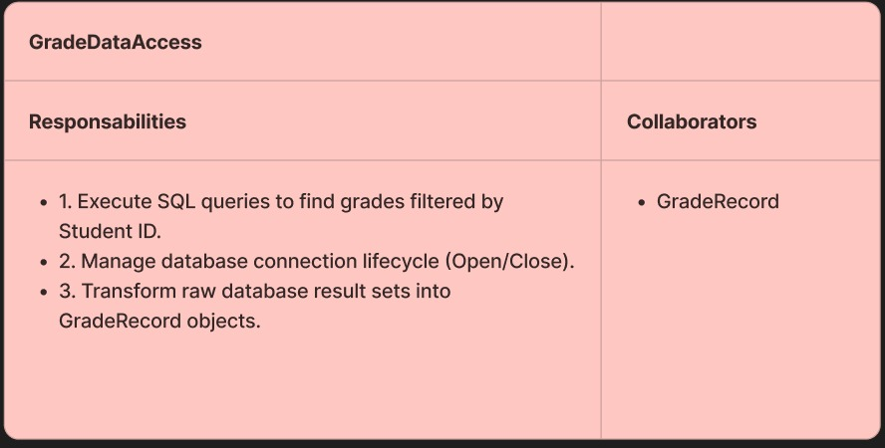
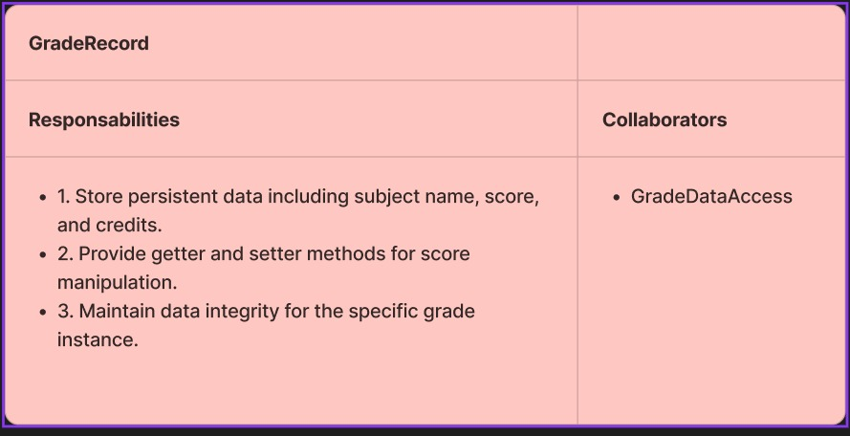

Updated Class Diagram :
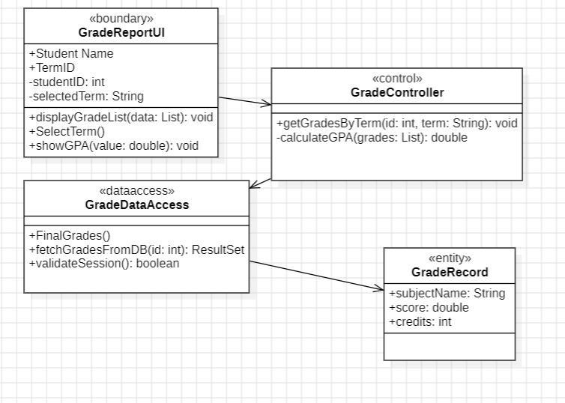
2. Use Case Name: View Attendance (Simple)
- Scenario: User monitors daily attendance status (Present/Absent).
- Triggering event: User selects “Attendance History.”
- Brief description: Displays a calendar or list view of a student's attendance records within a chosen date range.
- Actors: Primary: Student or Parent. Secondary: Teacher (who recorded it).
- Stakeholders: Students; Parents; School Administration.
- Related use cases: Record Attendance (attendance must be recorded first).
- Preconditions: * User is authorized to view the specific student's data.
  - AttendanceUI is initialized.
- Postconditions: * Attendance grid is rendered; total presence/absence summary is provided.
- Flow of activities:
  - Actor selects a month or date range in the AttendanceUI.
  - System (AttendanceController) requests records for that specific range.
  - System (AttendanceDataAccess) retrieves AttendanceRecords from the DB.
  - System computes the attendance percentage.
  - System highlights absent days in red and present days in green on the UI.
- Exception conditions:
  - Invalid date range (e.g., end date before start date) → show error message.
  - Database connection failure → notify user to try again later.

First Cut Design Class Diagram :
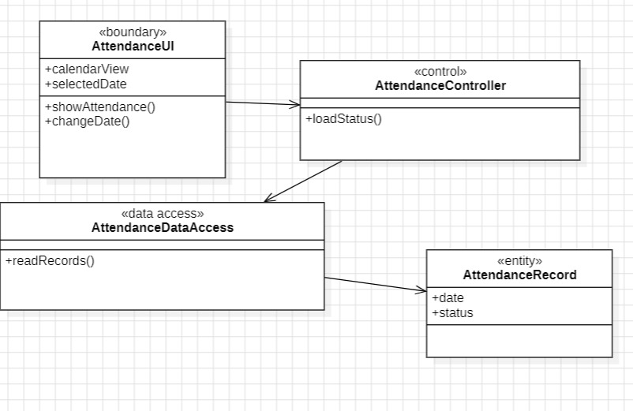

CRC Cards : 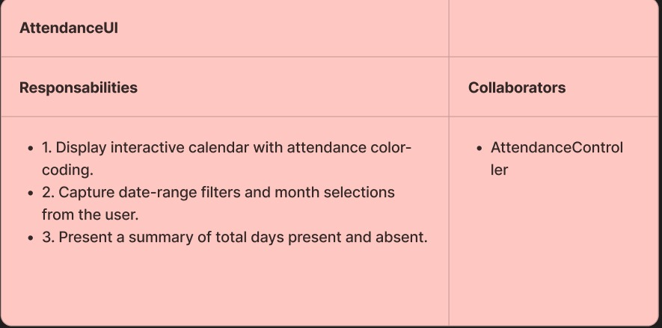
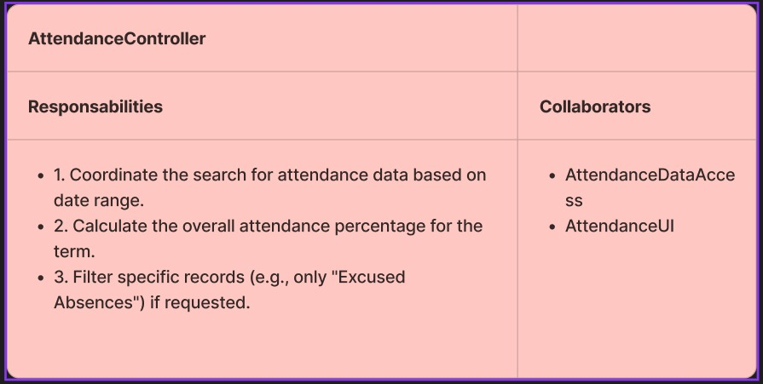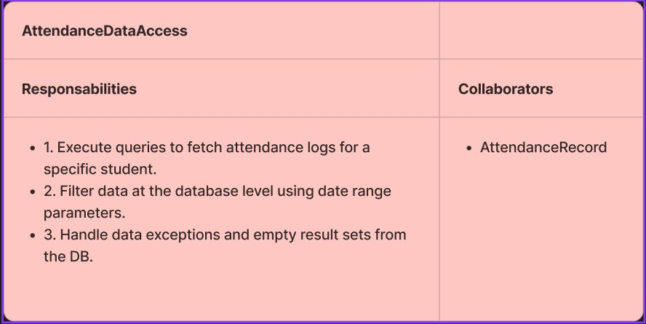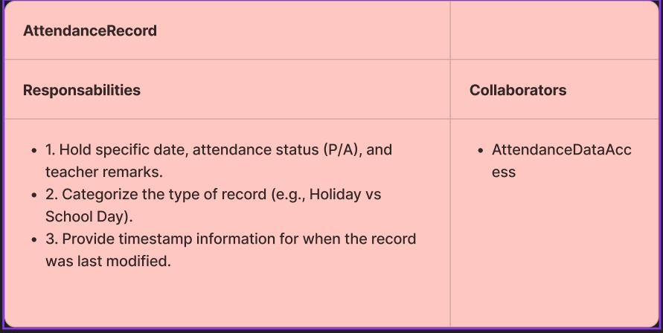
Updated Diagram :
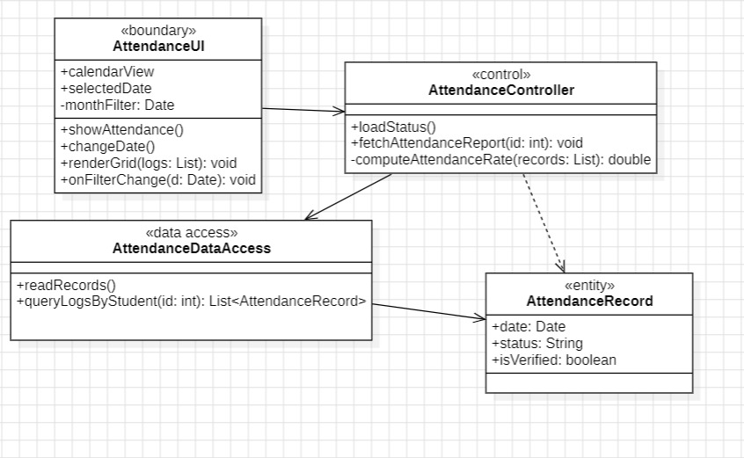

3. Use Case Name: View Announcements (Simple)
- Scenario: User reads school news, updates, or urgent notices.
- Triggering event: User navigates to the “Announcements” section or clicks a notification.
- Brief description: Provides a filtered list of announcements relevant to the user's role (Student, Parent, or Teacher).
- Actors: Primary: All Users (Student, Parent, Teacher, Admin).
- Stakeholders: Entire School Community.
- Related use cases: Announcements and Communication (creation of the post).
- Preconditions: * User is logged in (to determine role-based filtering).
- Postconditions: * List of active announcements is displayed; unread posts are marked.
- Flow of activities:
  - Actor requests to see the AnnouncementBoard.
  - System (AnnouncementController) checks the user’s role.
  - System (AnnouncementDataAccess) fetches non-expired posts for that role.
  - System sorts posts by urgency (priority) and date.
  - System displays the titles; Actor clicks a title to view full content.
- Exception conditions:
  - No active announcements → show "No new announcements" message.
First Cut Design Class Diagram : 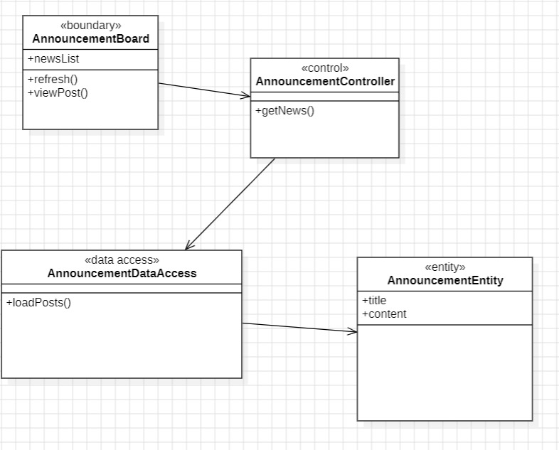

CRC Cards : 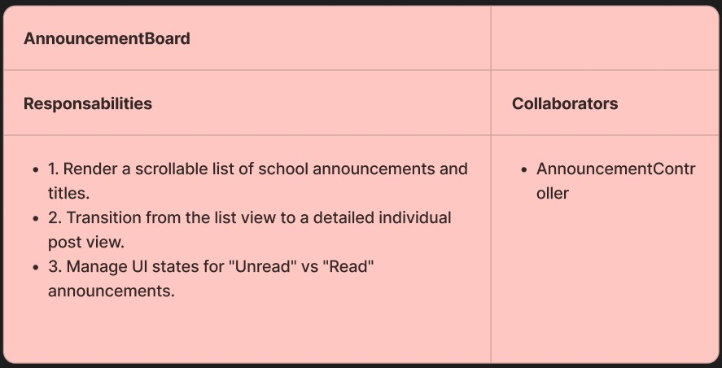

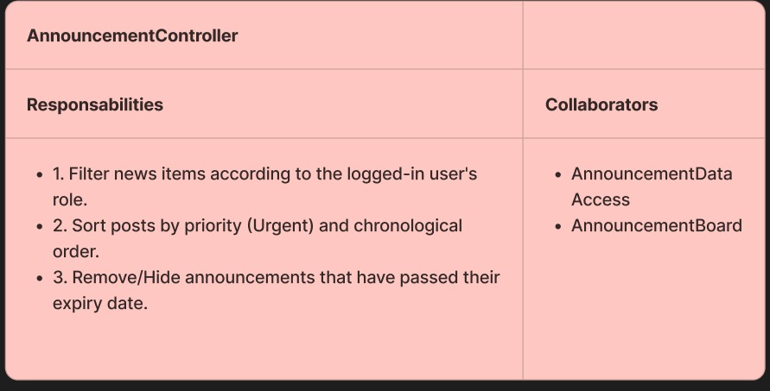
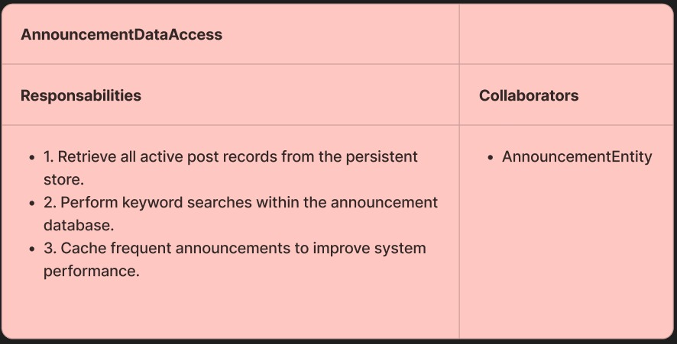
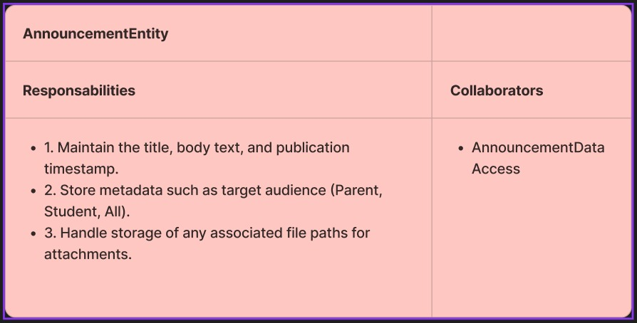
Updated Diagram : 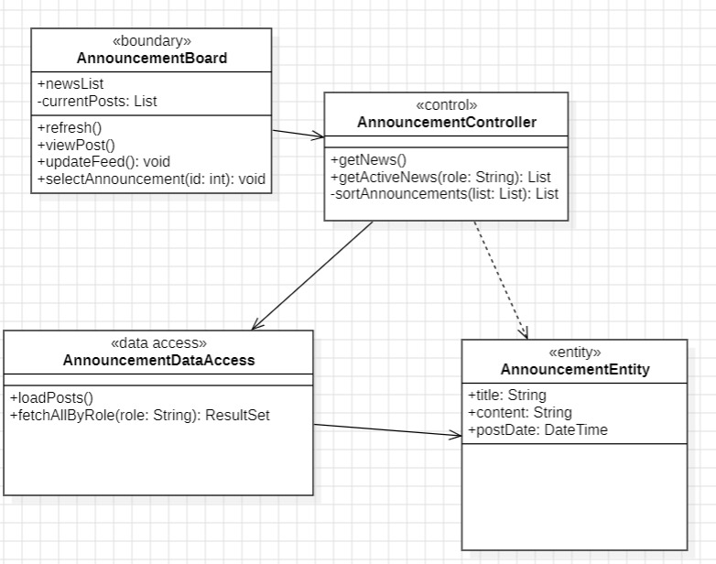

4. Use Case Name: Manage User Accounts (Profile Update)(Simple)
- Scenario: User updates their personal profile information or password.
- Triggering event: User clicks on “Profile Settings.”
- Brief description: Allows users to view their account details and update their password or contact info securely.
- Actors: Primary: Any registered User (Admin, Teacher, Student, Parent).
- Stakeholders: System Admin; All Users; Security/Audit Team.
- Related use cases: Manage User Accounts (Admin-side management).
- Preconditions: * User is authenticated and currently active in the session.
- Postconditions: * UserAccount entity is updated in the database; password is re-hashed.
  - Security log of the change is recorded.
- Flow of activities:
  - Actor requests “Profile Settings” and enters a new password or email.
  - System validates password complexity and matching fields.
  - System (AccountController) hashes the new password for security.
  - System (UserDataAccess) commits the update to the UserAccount record.
  - System confirms the success and sends a confirmation notification.
- Exception conditions:
  - Current password incorrect → reject change and notify actor.
  - New password does not meet complexity rules → show requirements error.
First Cut Design Class Diagram : 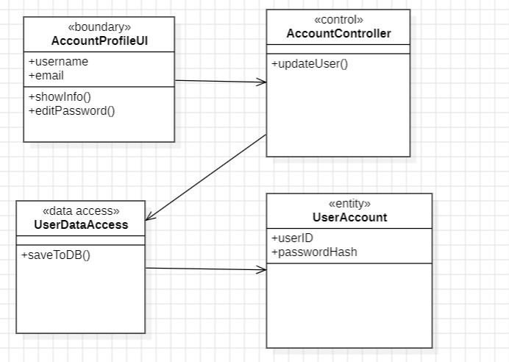
CRC Cards : 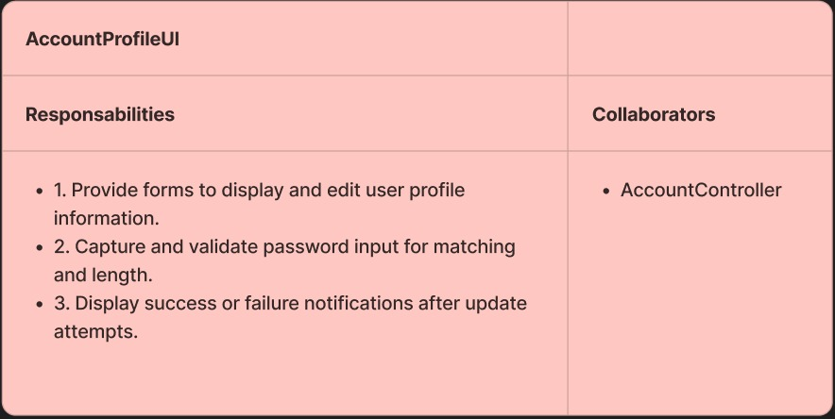
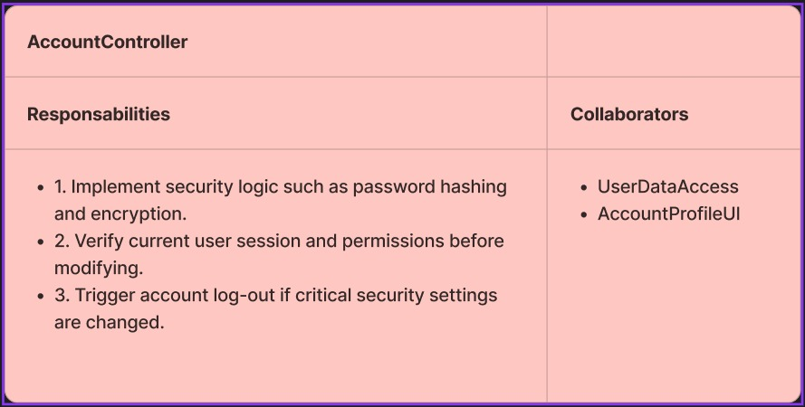
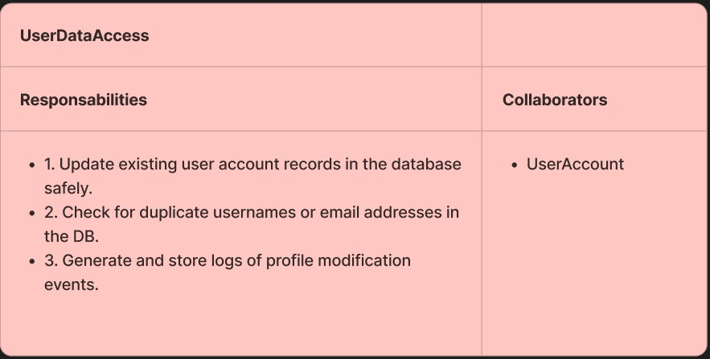
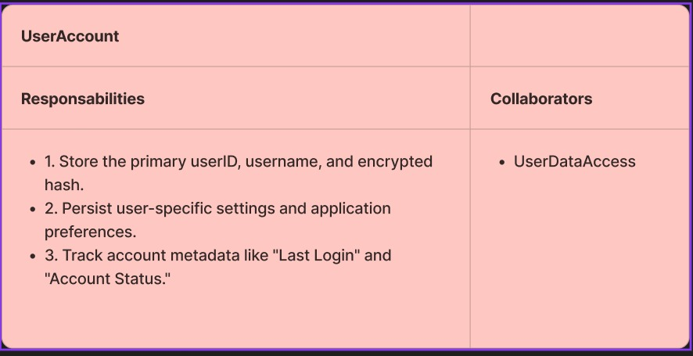
Updated Diagram : 